Assignment 9

Name: Jeevan Sai Badana

Mail: [jeevansai100@gmail.com](mailto:jeevansai100@gmail.com)

Date: 31-01-2024

Topic: JSON

**Various methods to get unique list**

**Using set method**

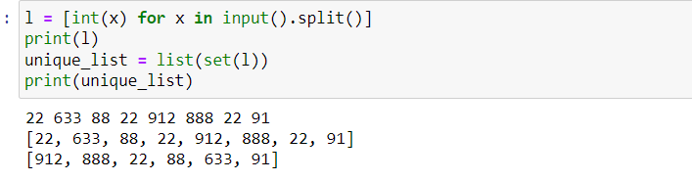

**using reduce() method:**

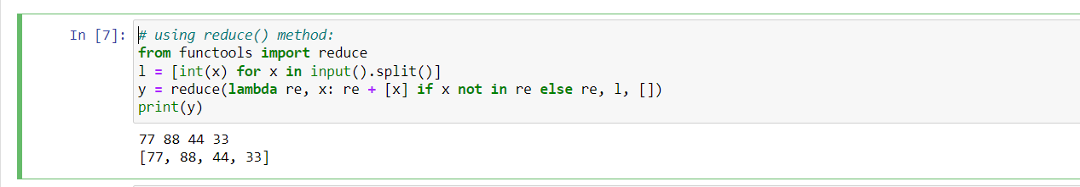

**using operator.countOf() method:**

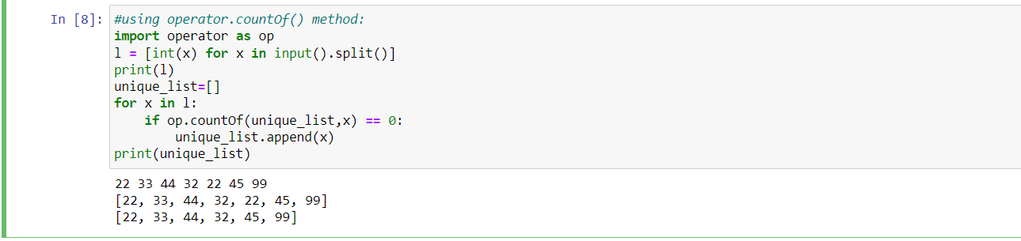

**using pandas module:**

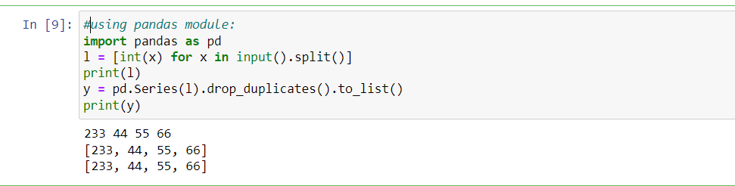

**using numpy.Unique method:**

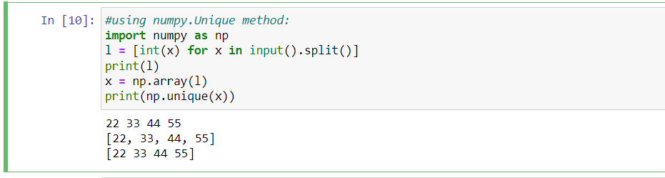

**using collection.Counter() method:**

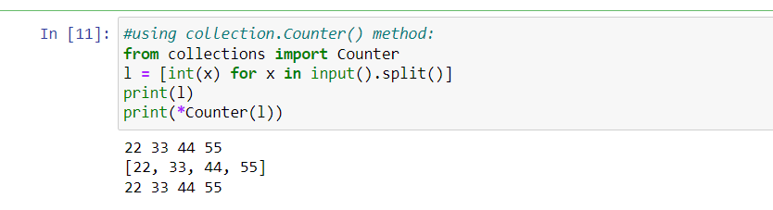

**using dict.Fromkeys():**

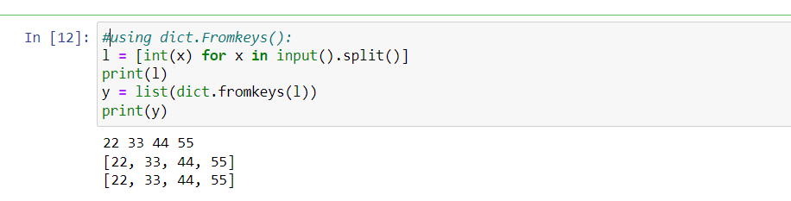

**Sort lists in python**

**using sorted():**

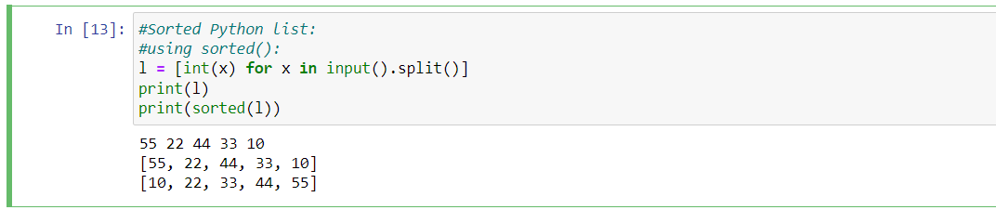

**using sorted() with reverse argument:**

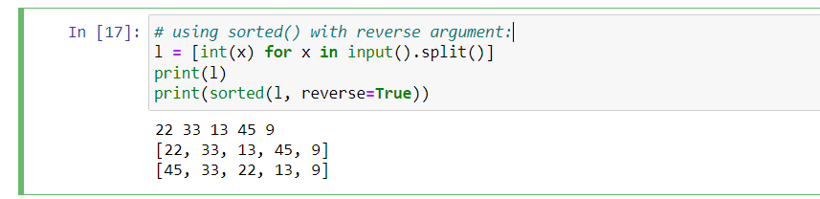

**using sorted() with key argument:**

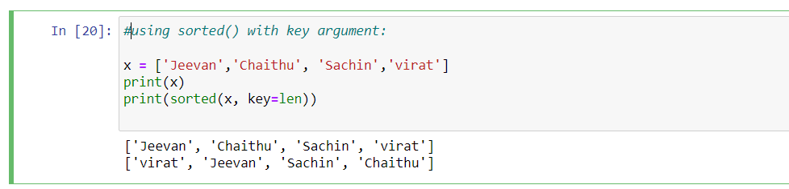

**JSON:**

* **JSON stands for JavaScript Object Notation.**
* **It is a format for structuring data.**
* **This format is used by different web applications to communicate with each other**
* **The official media type for the JSON is application/json and to save those files .json extension.**

**JSON string to Python Dictionary:**

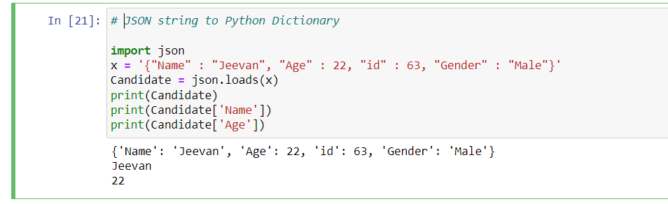

**Converting a json data inside a file into python dictionary:**

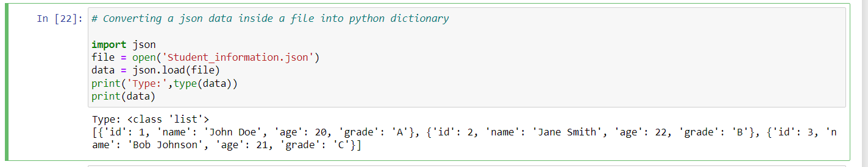

**Python Dictionary to JSON object:**

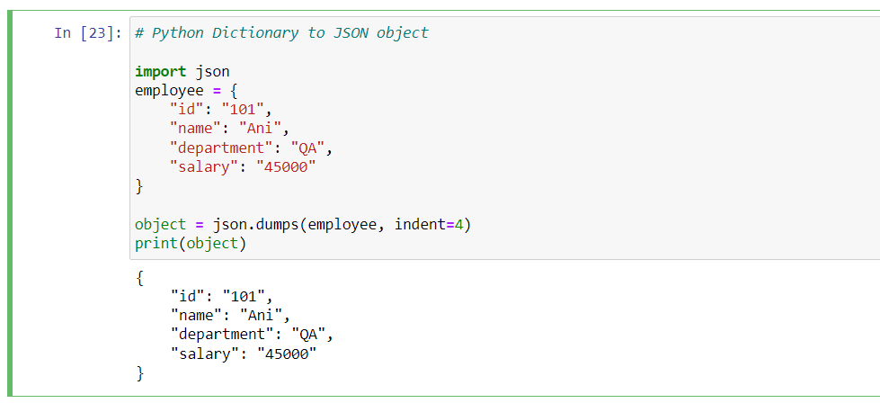

**JSON to a file in Python:**

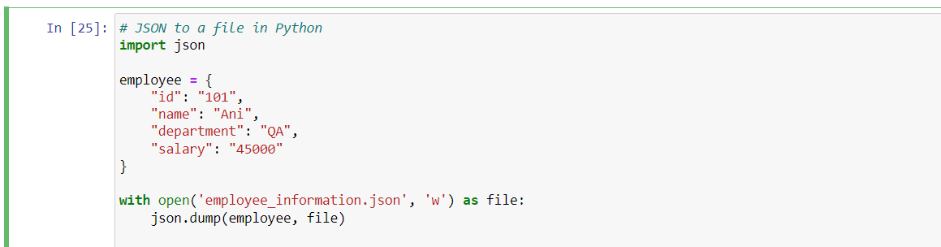

**Checking it is write or not**

